**Week 4 Assignment**

**Applied Data Science Capstone of the IBM Data Science Professional Certificate**

**submitted by Jochen Brosien**

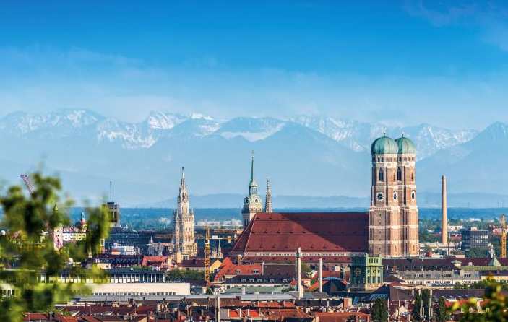

**Description of the Problem**

As a German living in the United States, I often get asked about where to go and what to see when Americans are visiting Germany. Being from Bavaria, I tend to make recommendations about visiting Munich, being world known about the annual Octoberfest, the English Garden (comparable to the Central Park in New York City), Nymphenburg Palace (home of the Bavarian kings), beer gardens, Lederhosens, beer steins, and more. While doing the research for a self-chosen topic of the Applied Data Science Capstone Project, I came to realize that there is a multitude of ways how you can inform yourself about Munich as a city, what to do, where to eat etc., but all the sources available (online guides, printed guides) lag the combination of touristic attraction and affordable places to stay.

The goal of this Capstone project is to provide insight and easily available information about where to stay, what to do and where to eat. While all this information is publically available in tourist guides and the internet, the goal is to pull all that data together in one centralized view.

**Description of the data and how it will be used**

As hotels in Munich, as a major tourist city, are fairly high for the average tourist, I am using an Airbnb dataset available on Kaggle (<https://www.kaggle.com/chriskue/munich-airbnb-data>). The actual and currently available dataset at <https://data.insideairbnb.com/germany/bv/munich/2020-04-25/visualizations/listings.csv>. The dataset was, for visualization purposes, updated by adding the available latitude and longitude data for the apartments. Germany, as part of the European Union, follows (compared to American laws) strict regulations regarding data and sharing thereof. For integrating neighborhood/district data for the city of Munich, I am also using a dataset posted on Kaggle, but available at <https://data.insideairbnb.com/germany/bv/munich/2020-04-25/visualizations/neighbourhoods.geojson>. The geojson file was converted to a .csv file so that it can be utilized within the Jupyter notebook application.

FourSquare will be utilized to retrieve data for Munich. The data includes venues like attractions, museums, or parks, and places to eat like restaurants or shops to eat. While using the developer account for FourSquare, the Food City Guide for Munich can be found at <https://foursquare.com/explore?mode=url&near=Munich%2C%20Germany&nearGeoId=72057594040795650&q=Food>.